**Bo Lontum**

**Linux assignment 1**

1. **Writing a command that prints out the string “ hellow, this is my first basic course” using two different ways, both with and without using quotation marks**

1. Typing a command that Echo ‘ how to get out of trouble(with a mismatched single quote), and then get out of trouble using the technique we have learned in class

1. The official short and long descriptions of ‘’echo’’ on my system according to the map page

1. Using the up arrow, print to the screen, the strings “we love what we are doing…

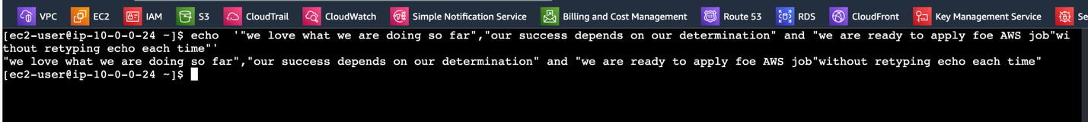

5. using your up-arrow key to recall the command, use any combination of ⌃A, ⌃E, to move   
your cursor.

